LoadSub User Handbook
  - How to set up your company share work run jobs and keep the commercial record complete
For company owners, managers and drivers using LoadSub private groups, managed subcontractor networks and the Public Network.
Edition 1 | 12 September 2026
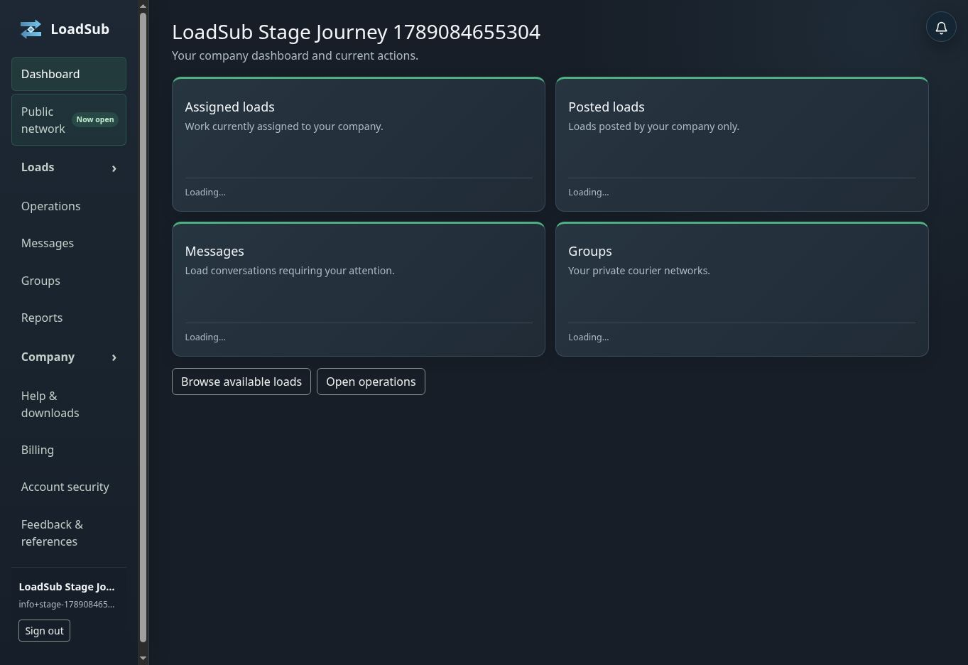
Real LoadSub staging dashboard populated with demonstration company data.
Purpose: This handbook explains not only where to click, but why each step exists, what LoadSub records, what the other party sees and what happens next.
Scope: Screens use a real staging account and demonstration data. No customer information is shown. Partner commission arrangements and platform administration are outside this user handbook.

START HERE

How to use this handbook
Use the quick FAQ when you need one answer. Use this handbook when you are learning a workflow, training a colleague or checking what should happen after an action.
If you need to | Go to
Set up a new company | Chapters 2 to 5
Build or join a private network | Chapters 6 and 7
Post or find work | Chapters 9 and 10
Bid, award and assign | Chapters 11 and 12
Run and finish a job | Chapters 13 and 14
Handle payment records or problems | Chapters 15 to 18

The complete LoadSub journey
- Register and verify the company account.
- Choose an onboarding goal and complete the relevant setup.
- Add colleagues, fleet and insurance evidence as needed.
- Create or join a private group, or choose a Public Network tier.
- Post a load or find suitable available work.
- Submit, compare and accept a bid.
- Assign the vehicle and driver.
- Record the job stop by stop.
- Submit and review POD.
- Agree additional charges and issue the invoice.
- Retain the messages, evidence and audit history with the load.
The central idea: LoadSub keeps discovery, price, assignment, instructions, evidence and invoicing attached to one load record. That is what prevents the handover gaps common in chat groups and spreadsheets.

CHAPTER 1

Roles responsibilities and visibility
A company is not permanently a poster or carrier. It becomes the poster when it publishes a load and the carrier when its bid is accepted. Company roles control what each signed-in person may do.
Role | Main responsibility | Typical access
Owner | Controls the company and commercial account | Billing, users, settings and all operational work
Manager | Runs day-to-day transport work | Post, bid, assign, review POD and issue invoices
Driver | Completes assigned work | Assigned instructions, stops, evidence and POD

Group roles
- The group owner controls the private network, invitations, rules, insurance requirements and sponsored memberships.
- A group administrator acts only within the permissions granted by the owner.
- Group membership is separate from company role. A company can belong to a group without every employee becoming a group administrator.
Why this matters: If an action is missing, first check whether the signed-in person has the relevant role. The interface hides actions that the API would reject anyway.

CHAPTER 2

Registration verification and first sign in
Registration creates both the company record and its first owner account. Email verification proves that the address can receive security and operational messages.
- Open Register from the public site or service.
- Enter genuine company and owner details.
- Open the newest verification email and confirm the address.
- Sign in with the verified address and password.
- Choose the onboarding goal closest to the work you want to do first, or choose Pick later.

Why only the newest email works
A fresh security email replaces earlier verification links and codes. This prevents an older message being used after a newer security request. Repeatedly requesting messages can therefore make the message already open in your inbox invalid.
What happens next: LoadSub opens the company dashboard. The progress marker now follows the selected goal and ticks off completed work automatically.

CHAPTER 3

Your dashboard and onboarding goal
The real staging dashboard. The next setup step is shown before the work-area cards.
The dashboard answers two questions: what needs attention now, and where is each kind of work? The goal panel is a guide, not a restriction. You can still use other areas and change the goal later.
Area | What appears there | What normally happens next
Available loads | Work visible to your company | Open a load and bid
My bids | Offers submitted by your company | Amend, withdraw or wait for a decision
Assigned loads | Work awarded to your company | Assign operational resources
Operations | Live journeys and stops | Record milestones and POD
Posted loads | Loads your company published | Review bids, award or manage the load
Messages | Load-linked conversations | Reply in the correct commercial context

Counters: The first figure is the total. The second is the new or pending subset. A pending figure means attention may be needed; it does not override permissions or the record state.

CHAPTER 4

Company details users and security
Complete the details that LoadSub reuses in operational and commercial records. Trading name, contact details, VAT position, payment terms, bank details and logo should be accurate before the first invoice.

Adding people
- Open Company and Users.
- Invite the person using their own email address.
- Assign only the roles they need.
- Ask them to verify and sign in using their own account.
- Remove or lock access promptly when it is no longer needed.
What happens next: Once accepted, the person works inside the same company but sees only actions allowed by their role. Removing them ends active sessions without erasing historic responsibility.

Two factor authentication
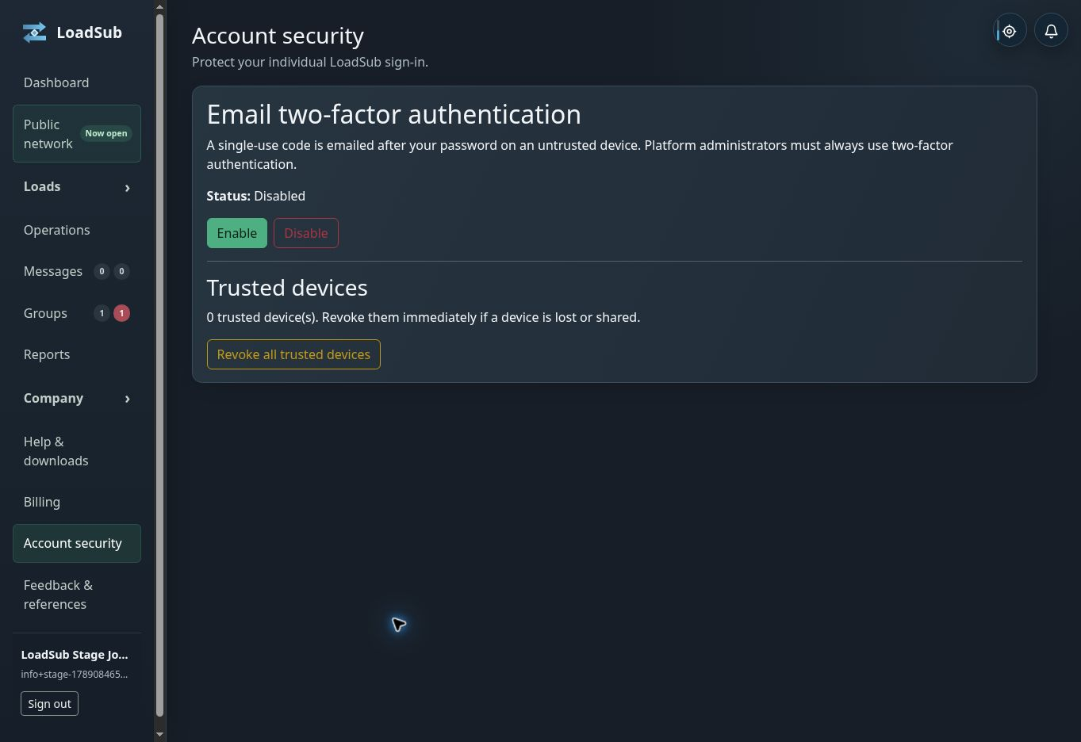
The real Account security screen. Two factor authentication is optional for ordinary company accounts.
- Enable email two factor authentication for extra protection after the password step.
- Trust only a private browser on a device you control.
- Signing out ends the signed-in session; trusting a device does not keep the session open.
- Revoke trusted devices immediately if a device is lost, sold or shared.

CHAPTER 5

Fleet and insurance setup
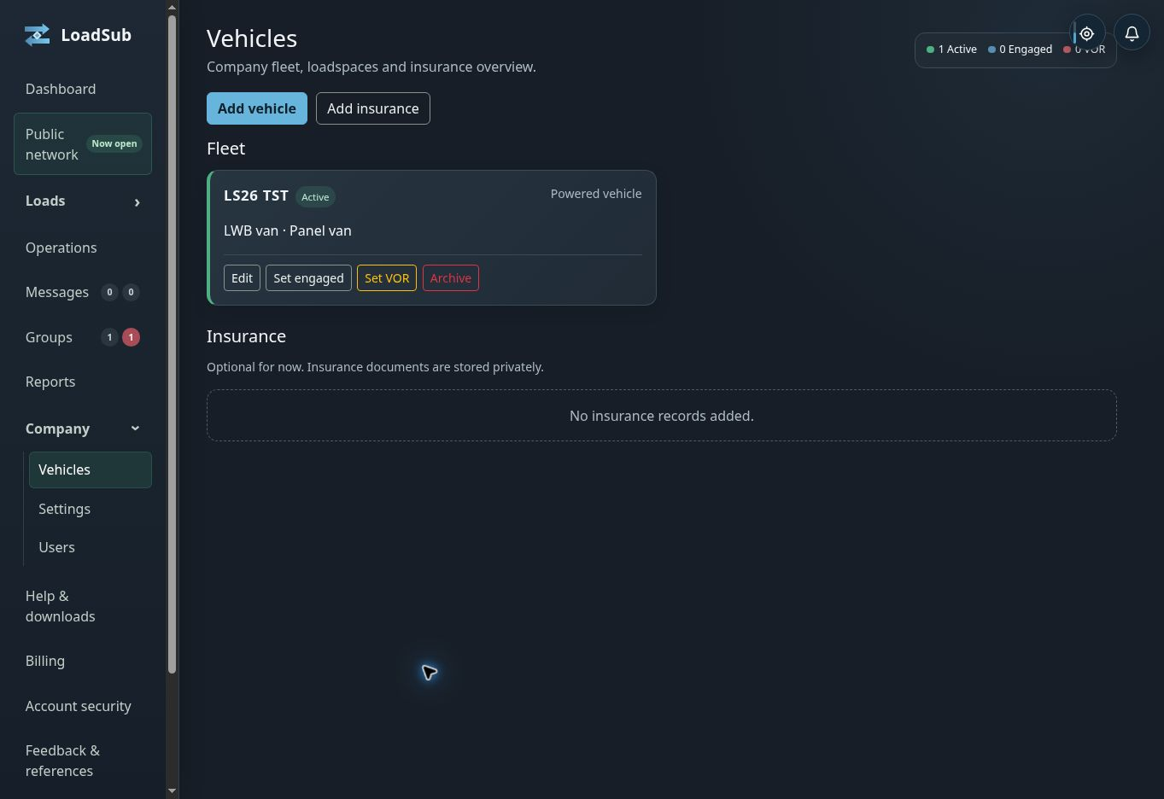
The real staging fleet with one demonstration vehicle. Status controls sit with the asset.
Fleet records help match and assign realistic resources. Insurance records demonstrate compliance with the different rules chosen by each private group.
Status | Meaning | Use
Active | Available for matching and assignment | Normal available resource
Engaged | Committed to work | Automatic on assignment or set manually
VOR | Vehicle off road | Set manually until the vehicle returns

Add a powered vehicle or trailer
- Choose Add vehicle.
- Select the asset type, vehicle class and body or load-space type.
- Enter the registration or identifier and useful dimensions or capabilities.
- Save it as Active only if it can genuinely be offered for work.

Insurance findings
A group may mark a cover type Not required, Advisory or Mandatory. Advisory findings warn. A mandatory failure can block new bids in that group after any configured grace period, while legitimate assigned work remains available to complete.
What happens next: The vehicle becomes available in bidding or assignment where it meets the load and company conditions. Insurance is checked against the rules of the group through which the load is visible.

CHAPTER 6

Creating and growing a private group
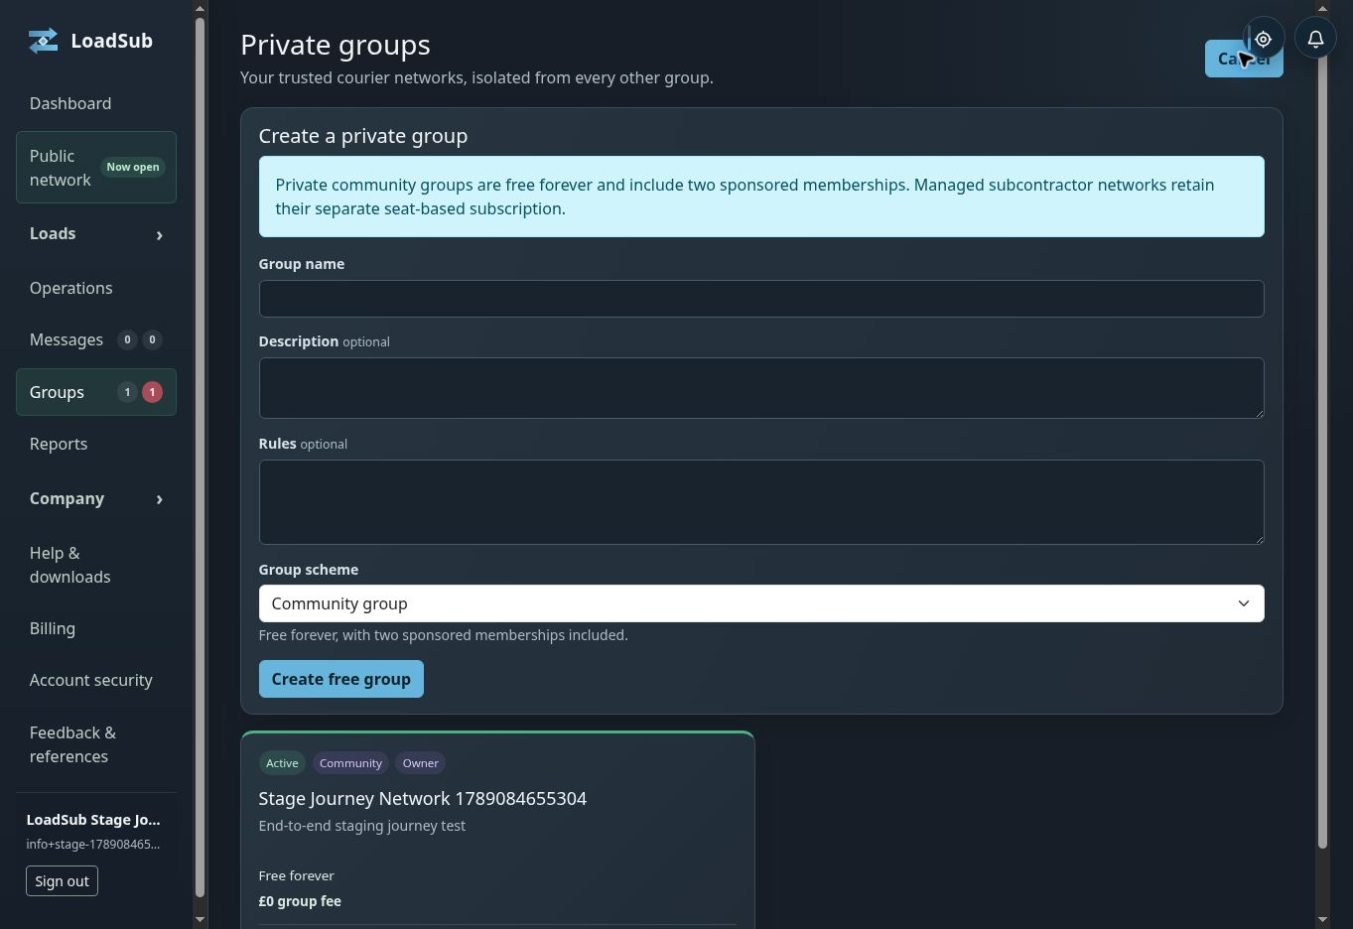
The real private-group list with a demonstration community group.
A private group recreates the trusted membership of an existing courier network while moving the work itself into structured records. Private community groups are free forever and include two sponsored company memberships.
- Open Groups and choose Create group.
- Choose Community group or Managed subcontractor network.
- Add the name, purpose and rules members should understand.
- Set insurance requirements suitable for the work shared there.
- Create an invitation and send it to companies you already trust.

Community group or managed network
Type | Best for | Member capability
Community group | Peer companies sharing work | Approved full companies can post and bid
Managed subcontractor network | A transport team issuing work to its subbies | Restricted accounts receive and operate invited work

What happens next: Applicants accept the current rules and apply. Nothing becomes visible to them until an owner or permitted administrator approves the application.

CHAPTER 7

Managing a group after creation
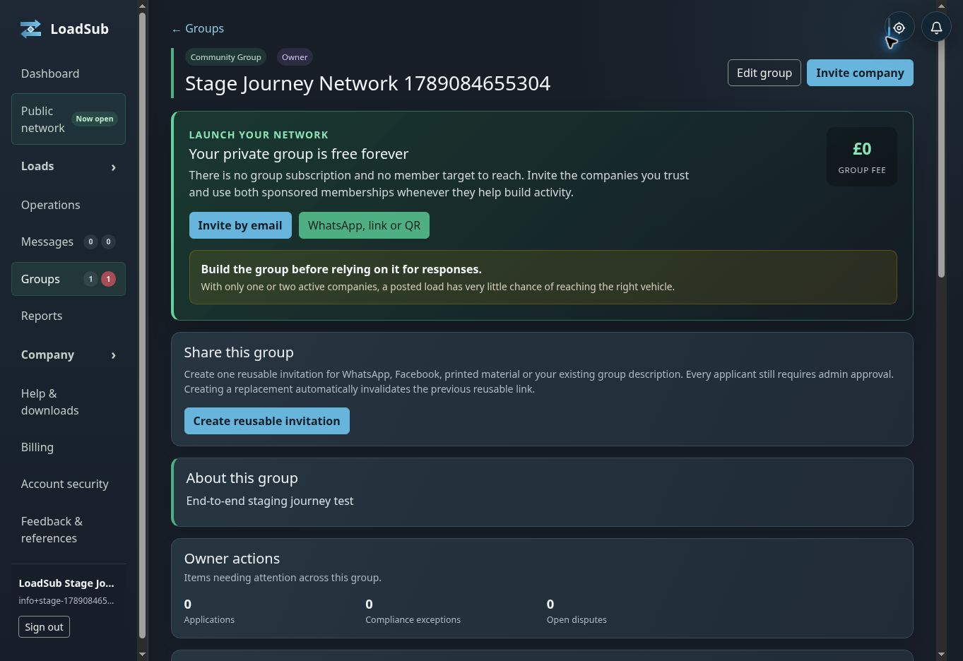
The real group owner view with invitations, activity and insurance controls.
The group owner view combines launch actions, member administration, compliance rules and private activity information. The objective is to build a useful pool before relying on the group for urgent responses.
- Invitation links can be reused for WhatsApp, Facebook, printed material or direct sharing. Every applicant still requires approval.
- Material changes to group rules or insurance policy require members to acknowledge the new version.
- Bidding can be paused for a company during an investigation without removing its membership or history.
- Ordinary members see only the safe fleet and insurance overview allowed by the group.
- Commercial performance information belongs to the group owner, not the general member directory.

Leaving closing and history
A group closure stops new invitations, discovery and bids, but does not erase legitimate assigned work, POD, invoices, membership history or the audit trail. This separation lets the network close without destroying commercial evidence.

CHAPTER 8

Joining an existing private group
- Open the invitation link supplied by the group.
- Sign in, or register and verify the company first.
- Read the current group rules and insurance requirements.
- Submit the application.
- Wait for approval from the owner or administrator.

What the group owner sees
The application identifies the company and its acceptance of the current rules. The owner reviews it before any group work becomes visible. The invitation is therefore an entry point, not automatic membership.

What you see after approval
The group appears in Groups, and eligible loads shared into it can appear in Available loads. Whether you may bid still depends on company access, any bidding pause and mandatory insurance compliance.
What happens next: Set the group-specific new-load alert preference, check the group rules and confirm that any required insurance evidence is current before relying on alerts.

CHAPTER 9

Finding suitable work
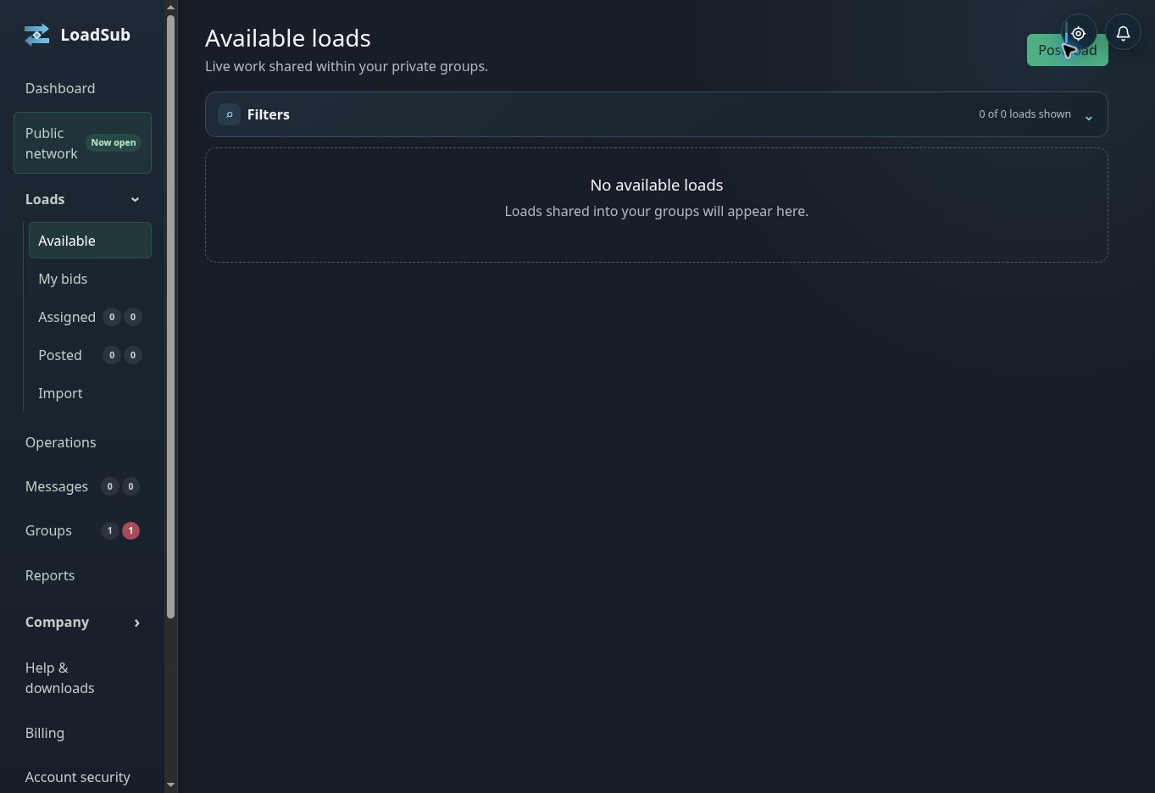
The real Available loads screen. The filters remain useful even when this demonstration company has no current work.
Available loads is a private discovery view. It combines work shared into groups your company can access and, where subscribed, eligible Public Network work.
- Filter by group, collection or delivery area, timescale, vehicle requirement, co-load setting and poster.
- Use radius search only when proximity is useful; clear it if the result set becomes unexpectedly narrow.
- Open the load to inspect every public requirement before pricing.
- Do not assume a missing load was deleted: it may have closed, been awarded, moved out of the filter or become unavailable through membership or compliance.

Information before award
Eligible bidders see public postcodes, ordered stops, timescale, requirements and public notes. Full addresses, site contacts, confidential references and protected instructions remain hidden until assignment.
What happens next: Open a suitable load and either ask a private load-linked question or prepare a bid. Other bidders cannot see your price or private thread.

CHAPTER 10

Posting a load
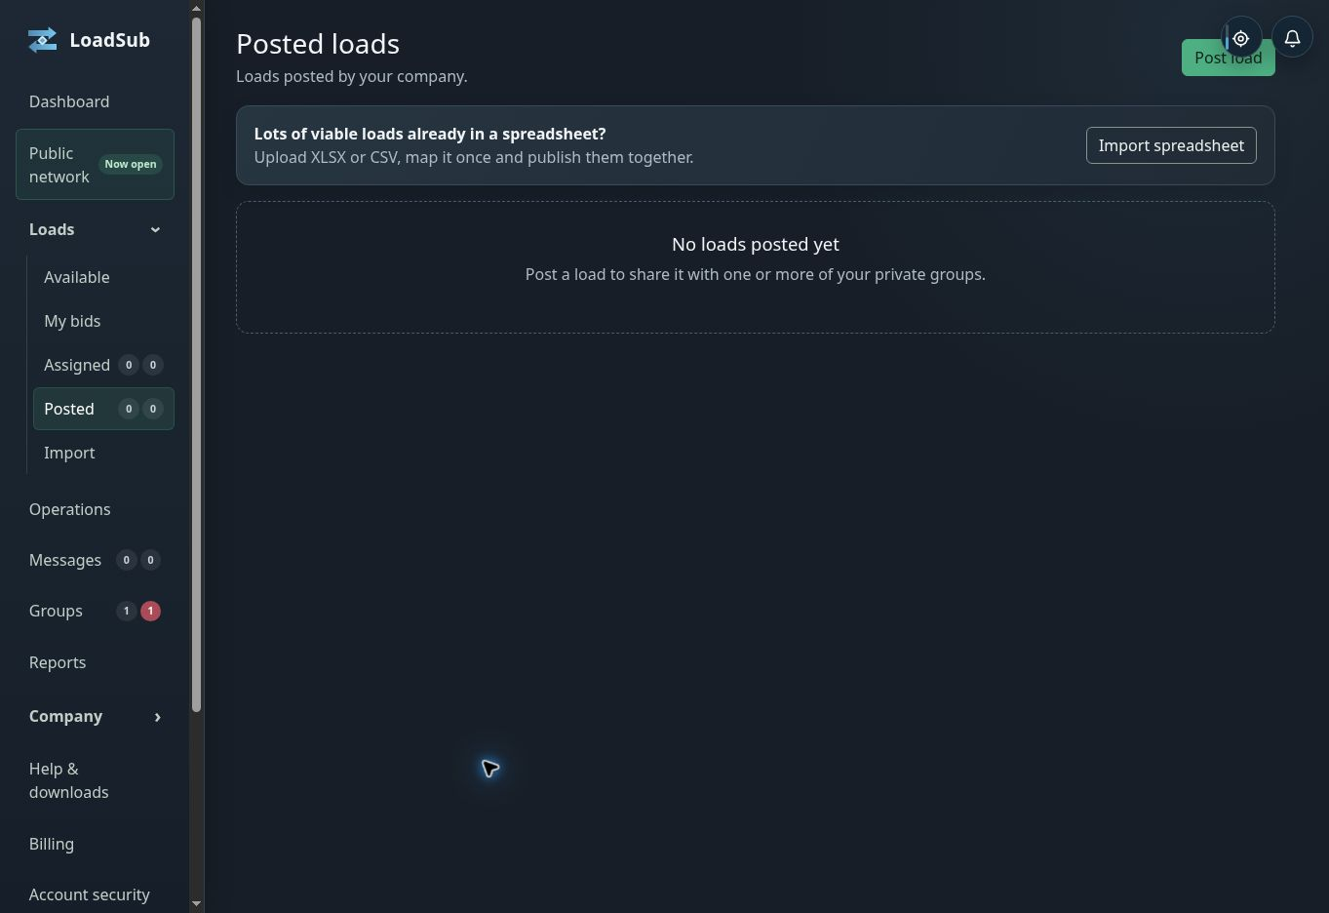
The real Posted loads screen. Loads can be entered individually or imported from a spreadsheet.
Posting converts an informal request into a record that can be found, priced and handed over without copying instructions between chats.
- Choose Post load.
- Select every eligible private group that should receive the same load.
- Add collection and delivery postcodes and any additional ordered stops.
- Set timescale, description, public notes and the vehicle or load requirements that matter.
- Put full addresses, contacts, access details and confidential references in protected stop fields.
- Choose whether co-loading is allowed; it is disallowed unless you explicitly permit it.
- Review the public view before publishing.

One load shared to several groups
Sharing to several groups does not create duplicate jobs. It remains one load and one bid pool. A bidder sees only the group through which it obtained access, and one accepted bid closes the load everywhere.

Goods and trailer movements
A load may describe goods movement or trailer movement. Trailer work can record live-load, tip, reload, collect, drop, swap, couple and uncouple actions. Each leg records its powered vehicle and whether it ran Solo, with a carrier-owned trailer or with an external trailer. Customer and third-party trailers are custody records rather than fleet assets.
What happens next: The load appears in Posted loads and becomes discoverable by eligible companies. Notifications are sent according to platform, company, user and group preferences.

CHAPTER 11

Bidding and private questions
A bid is a private commercial offer from one company to the poster. LoadSub does not expose it to competitors and does not automatically choose a winner.
- Open the available load and confirm every stop and requirement.
- Choose a suitable saved vehicle, or create one inline if offered.
- Enter the total GBP price, estimated mileage and whether the offer assumes co-loading.
- Add a useful note or permitted timing proposal.
- Submit, then monitor My bids and the private message thread.
Before acceptance | After acceptance
The bidder may amend or withdraw while the workflow permits. | The accepted price and commercial details are frozen in the audit snapshot.
The poster may compare price, mileage, time and ex-VAT £ per mile. | Other bids close unsuccessful when one offer is accepted.
Material load changes require bidders to reconfirm. | Cancellation or withdrawal becomes a negotiated formal process.

What happens next: The poster reviews eligible bids. If yours is accepted, the company becomes the assigned carrier and receives the protected operational details required for the job.

CHAPTER 12

Awarding and assigning work
Award and assignment are separate decisions. The poster chooses the carrier. The carrier then chooses the people and equipment that will actually perform the work.

For the poster
- Open the load in Posted loads.
- Compare eligible bids and any private clarification.
- Accept the chosen offer.
- Confirm that the accepted carrier now appears on the load.

For the carrier
- Open the award in Assigned loads or Operations.
- Select an eligible driver and powered vehicle.
- Select the operational trailer or combination where relevant.
- Save the assignment and check that the driver can see it.
Why equipment is chosen now: The practical combination may change between bidding and dispatch. LoadSub freezes the offered vehicle description at bid acceptance but records the actual operational resources at assignment.
What happens next: The assigned driver receives the operational record allowed by their role, including confidential stop information. The job is now ready to run in Operations.

CHAPTER 13

Running the job stop by stop
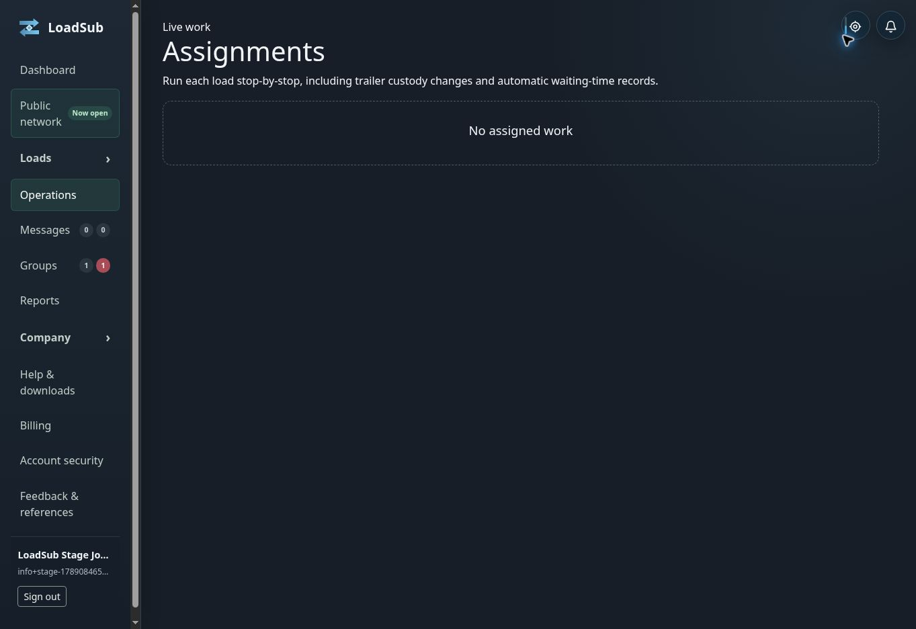
The real Operations screen for the demonstration company. Assigned jobs appear here when work is awarded.
Operations turns the agreed work into timed evidence. Record events in the order they happen so the poster, carrier and later invoice share one history.
- Open the assigned job before departure and review protected instructions.
- Record journey start when the movement begins.
- At each stop, record arrival before loading, unloading or waiting.
- Complete the required goods or trailer action.
- Record partial completion or failure honestly when the planned action did not complete.
- At the final required stop, complete the job and continue to POD.

Waiting time
Arrival starts the waiting-time clock and completion stops it. A carrier manager may propose waiting, demurrage or another additional charge. The poster approves or disputes the extra; a disputed extra does not prevent the base invoice.

If the connection drops
Do not repeatedly press the same action. Restore connectivity, reload the operational record and confirm the last recorded milestone before continuing. If the expected action remains missing, report the load reference, action and approximate time.

CHAPTER 14

Proof of delivery and completion
POD connects the completed stop to the people, time and evidence involved. The required evidence depends on the stop and may include recipient name, signature, signed paperwork, photos, notes and automatic timestamps.
- Open the POD-required stop after completing its operation.
- Record the recipient and required evidence.
- Review images and notes before submission.
- A driver-only user submits the evidence to a manager for review.
- A manager or owner reviews and sends it to the poster.

Who receives it
The assigned carrier and load poster can see completed evidence. The poster receives the LoadSub POD; the poster’s end customer is not contacted automatically. Access follows the load relationship, not general group membership.
Important: Nothing should send automatically before the carrier review step. Original evidence and modification history remain attached to the load.
What happens next: Once the load is complete and commercial extras are resolved, the carrier can prepare the connected invoice.

CHAPTER 15

Charges invoices and payment status
LoadSub keeps the carrier-to-poster invoice connected to the load. It does not move the underlying transport payment and does not take a percentage of the job value.
- Check that the load is complete and POD is available.
- Confirm which additional charges were approved.
- Review VAT status, carrier invoice number, payment terms, bank details and poster details.
- Create the draft invoice.
- Review and send it through LoadSub.
- Update the invoice status when it is paid or disputed.
Status | Meaning
Draft | Not yet issued
Sent | Issued to the poster
Paid | Carrier has recorded receipt
Overdue | Past the recorded terms
Disputed | Commercial issue remains open

What happens next: The poster receives the invoice and the commercial record remains linked to the accepted bid, approved extras and POD.

CHAPTER 16

Messages changes cancellations and disputes
Use the load-linked message thread for questions and operational communication. This keeps site details, prices and decisions away from unrelated group members and attached to the correct job.

Material load changes
A material change can affect the price or ability to perform the work, so existing bidders must reconfirm. Minor public detail additions notify bidders without automatically invalidating offers.

After assignment
Neither party simply deletes the agreement. The poster requests cancellation or the carrier requests withdrawal. The other party accepts, rejects or negotiates a charge. If the parties cannot agree, the matter may become a formal group-admin dispute.

Reopening a load
If a carrier withdrawal is agreed, the poster may close or reopen the load. Previous bids are not silently restored: bidders are notified and must reconfirm, and new bids may be made. LoadSub does not choose an automatic fallback carrier.
What happens next: A completed change or dispute remains in the audit history. Relevant evidence becomes available only to the people permitted to handle the case.

CHAPTER 17

Reputation references and notifications
Verified feedback is tied to completed LoadSub work. Business references are separate and may describe a genuine relationship that did not begin with a LoadSub assignment.
- Completed assignment partners may leave Positive, Neutral or Negative feedback and the reviewed company may reply.
- A positive-feedback percentage appears only after at least five scored reviews.
- The reviewed company may flag a review and provide private counter-evidence for adjudication.
- External profile links or screenshots remain company supplied and do not become LoadSub-verified reviews.
- Attach only evidence relevant to the relationship or assignment.

Notifications
In-app, email and supported browser alerts are resolved from platform rules, company defaults, user preferences and group-specific load alerts. Critical events may still require in-app and email delivery even when optional alerts are reduced.

CHAPTER 18

Membership billing and access changes
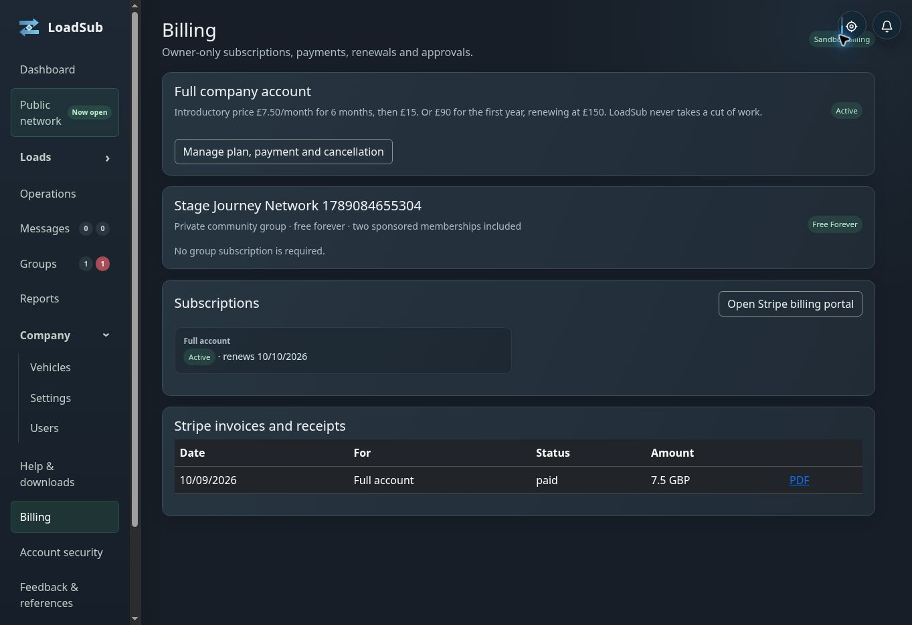
The real staging Billing page. Subscription controls are visible only to the company owner.
The company owner manages subscriptions, payment methods, receipts, plan changes and cancellation. LoadSub subscription charges are separate from the value paid between poster and carrier.
Item | Current user-facing rule
Full company trial | 30 days of operational access without a payment card
Private community groups | Free forever, with two sponsored memberships
Company membership | Introductory and standard monthly or annual prices shown in Billing
Managed subcontractor network | Separate seat-based subscription after its evaluation
Public Network | Post Loads or Post and Bid tier; annual option includes two months free

When access becomes read only
An expired trial or failed-payment outcome can prevent new commercial activity. Legitimate assigned work, POD, invoices and company history remain available as the service permits, so loss of subscription does not erase evidence or strand an active job.

Public Network
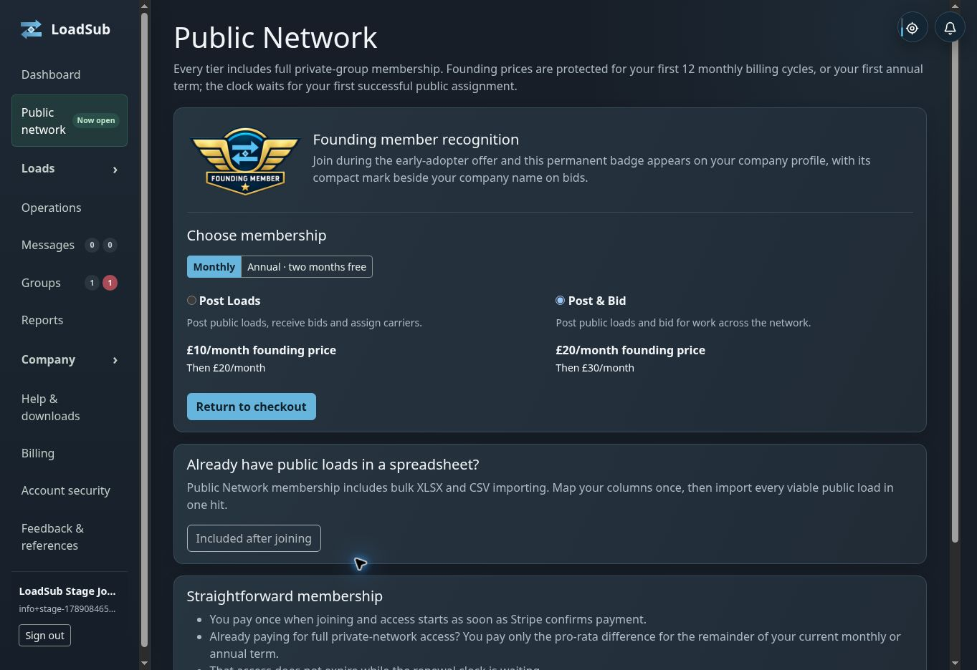
The real Public Network membership page showing tier purposes and founding-price information.
No load commission: LoadSub takes 0 percent of a load, bid, carrier payment or user invoice value.

REFERENCE

Troubleshooting by symptom
Symptom | Check in this order
A load is missing | Group membership; filters; bidding pause; insurance; load closed or awarded
A button is missing | Your role; company access; billing; record state; relationship to the load
A vehicle is unavailable | Ownership; Active status; suitability; conflicting engagement
A bid is blocked | Membership; pause; mandatory insurance; company access; own-company load
A counter disagrees | Open the page; clear filters; reload once; record both figures and time
An email or code fails | Use the newest message; check spam; avoid repeated requests
An operation may have duplicated | Stop; reload; confirm the last milestone before pressing again
Checkout appears to fail | Do not retry rapidly; check Billing; record the visible error and time

Before contacting support
- Include the page name, load or record reference, company role, exact error, time and timezone, browser or device, and whether one reload changed the result.
- Never include passwords, two factor codes, complete card details, session cookies or unrelated personal information.
- Contact info@loadsub.com.

REFERENCE

Glossary
Term | Meaning
Poster | The company that published the load
Carrier | The company whose bid was accepted
POD | Proof of delivery attached to the completed stop
VOR | Vehicle off road
Co-load | Carrying the load alongside other permitted work
Solo | A powered vehicle leg without a trailer
External trailer | A customer or third-party trailer held as a custody record
Private group | An invitation-only network of approved companies
Managed network | A transport team’s controlled subcontractor network
Sponsored membership | One of two group-owner-controlled company memberships
Trusted device | A private browser recognised for future two factor checks
Read only | History and permitted existing work remain visible, but new activity is restricted

REFERENCE

Quick operating checklists

Before posting
- Correct group or Public Network destination
- Public requirements complete
- Protected addresses and contacts in confidential fields
- Co-load choice deliberate
- Every stop and required action in the right order

Before bidding
- Access and insurance clear
- Every stop and requirement understood
- Vehicle realistic
- Mileage and total price checked
- Co-load assumption declared

Before dispatch
- Award confirmed
- Driver and actual equipment assigned
- Protected instructions reviewed
- Trailer custody and combination understood
- Driver can open the job

Before invoicing
- Stops completed
- POD reviewed and sent
- Additional charges approved or separated
- VAT and payment details correct
- Invoice number and terms checked

