LoadSub FAQ and User Guide
Practical guidance for accounts, groups, loads, bids, operations, delivery evidence and billing.
Updated and verified against the current LoadSub user journeys on 12 September 2026.

Start here
Register and verify your email, sign in, choose an onboarding goal, then use the progress marker to complete the setup relevant to your company. The guide follows the same path as the service and explains the common reasons an action may be unavailable.

Quick map
Area | Use it for
Available loads | Work your company may bid on
My bids | Offers submitted by your company
Assigned loads | Work awarded to your company
Operations | Journeys in progress and milestones
Posted loads | Work published by your company
Messages | Load-linked operational conversations

What controls access
Before reporting a missing button or record, check your role, company status, group membership, billing, insurance compliance, load status and active filters. These controls are deliberately combined, so a missing action is not always a fault.

01 Accounts sign in and security
Create and protect your company account, then control who can use it.
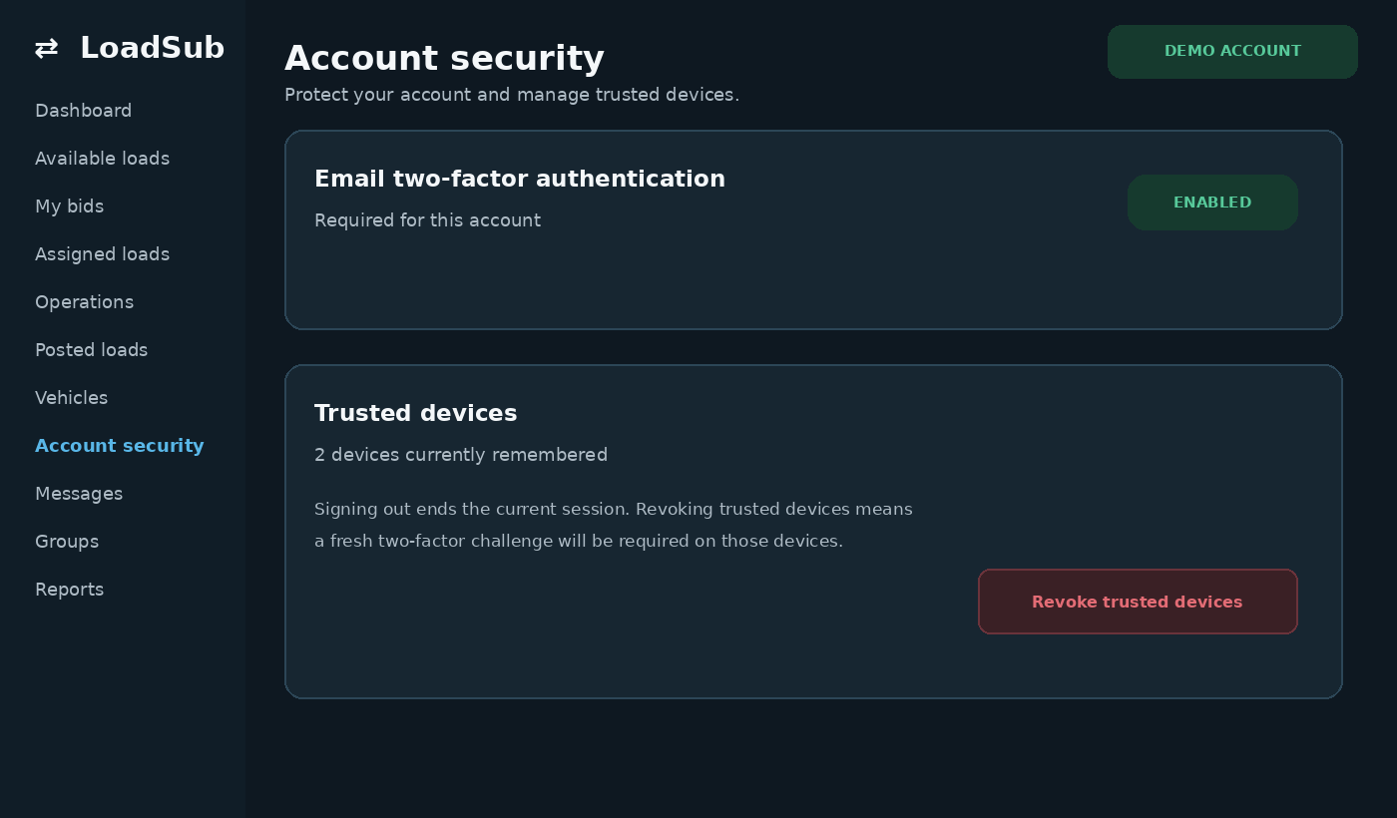
Synthetic LoadSub screen using demonstration data.

How do I create an account?
Choose Register, enter your company and account details, then open the newest verification email. After verification, sign in and choose the onboarding goal that best matches how you plan to use LoadSub.
- Confirm your address from the newest verification email.
- Sign in and choose a goal, or choose Pick later.
- Follow the suggested setup steps. Completed work is ticked off automatically.

Why am I being asked for a two factor code?
Two factor authentication is optional for ordinary company accounts. You will be asked for a code only after it has been enabled in Account security. Enter the newest emailed code.

What does trust this device mean?
It remembers that private browser for future two factor checks. It does not keep you signed in. Use it only on a device you control.

I did not receive an email
Check spam and filtered folders, confirm the address is correct, then request one fresh message. Use only the newest link or code because older ones are replaced.

02 Dashboard and navigation
Use the main work areas to move from finding work to completing it.
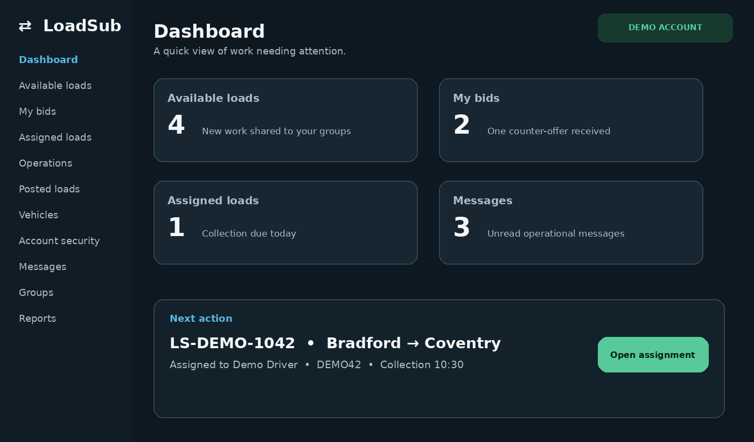
Synthetic LoadSub screen using demonstration data.

Where do I find each kind of work?
Available loads shows work you may bid on. My bids shows offers from your company. Assigned loads contains awarded work. Operations contains live journeys. Posted loads contains work your company published.

What do two numbers on a counter mean?
The first is the total in that area. The second is the new or pending subset. A pending count signals attention but does not guarantee that your role can perform the action.

How does onboarding progress work?
Choose the goal closest to your immediate job. The progress marker updates when relevant tasks are completed, and you can change the goal later.

A counter looks wrong
Reload once, open the destination page and clear any filters. If values still disagree, report both numbers, the page name and the observation time.

03 Company users and roles
Your company identity sits behind every load, bid and operational action.

Who can change company settings?
Owners and managers can maintain the profile and address book. Company access uses Owner, Manager and Driver roles, and one person may hold more than one operational role.

Why can another user see a button that I cannot?
Actions depend on role, company status, group membership, billing, insurance compliance and the current record state. A missing action may be correct.

What happens when a user is removed?
Their access and active sessions are revoked. Historical records retain the responsible person or company so the audit trail remains clear.

04 Vehicles trailers and insurance
Keep resources and compliance current before bidding or assigning work.
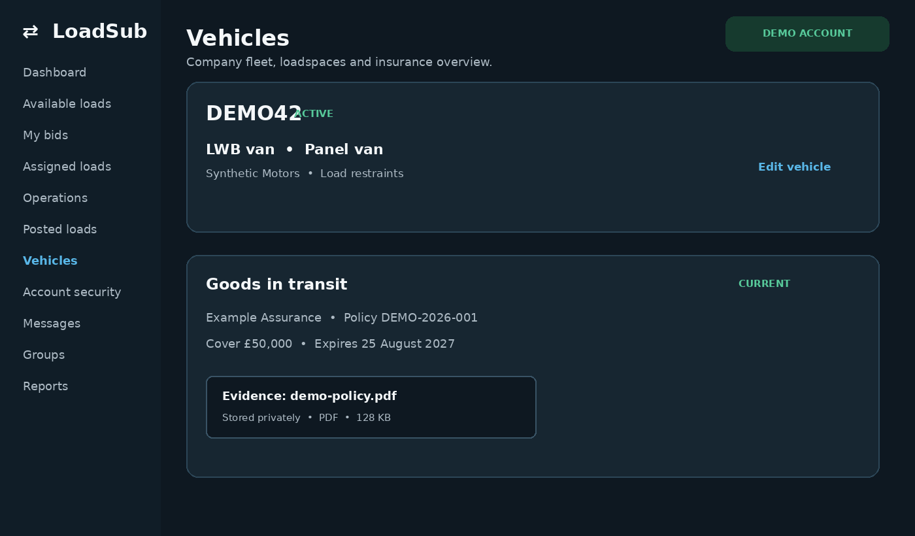
Synthetic LoadSub screen using demonstration data.

How do I add a vehicle or trailer?
Open Vehicles, choose Add vehicle and enter the matching fields, dimensions, capabilities and current status.

What do Active Engaged and VOR mean?
Active means available for matching. Engaged means currently committed. VOR means vehicle off road.

How is insurance assessed?
Each group can require cover types, values, evidence, expiry dates and grace rules. LoadSub compares your evidence with the rules for the group containing the work.

Why might insurance block a bid?
Open the named finding and correct the exact missing, insufficient or expired requirement. A generic upload will not satisfy a rule unless its type and dates match.

05 Private groups and subcontractor networks
Use private membership and proper controls instead of losing work instructions in chat.
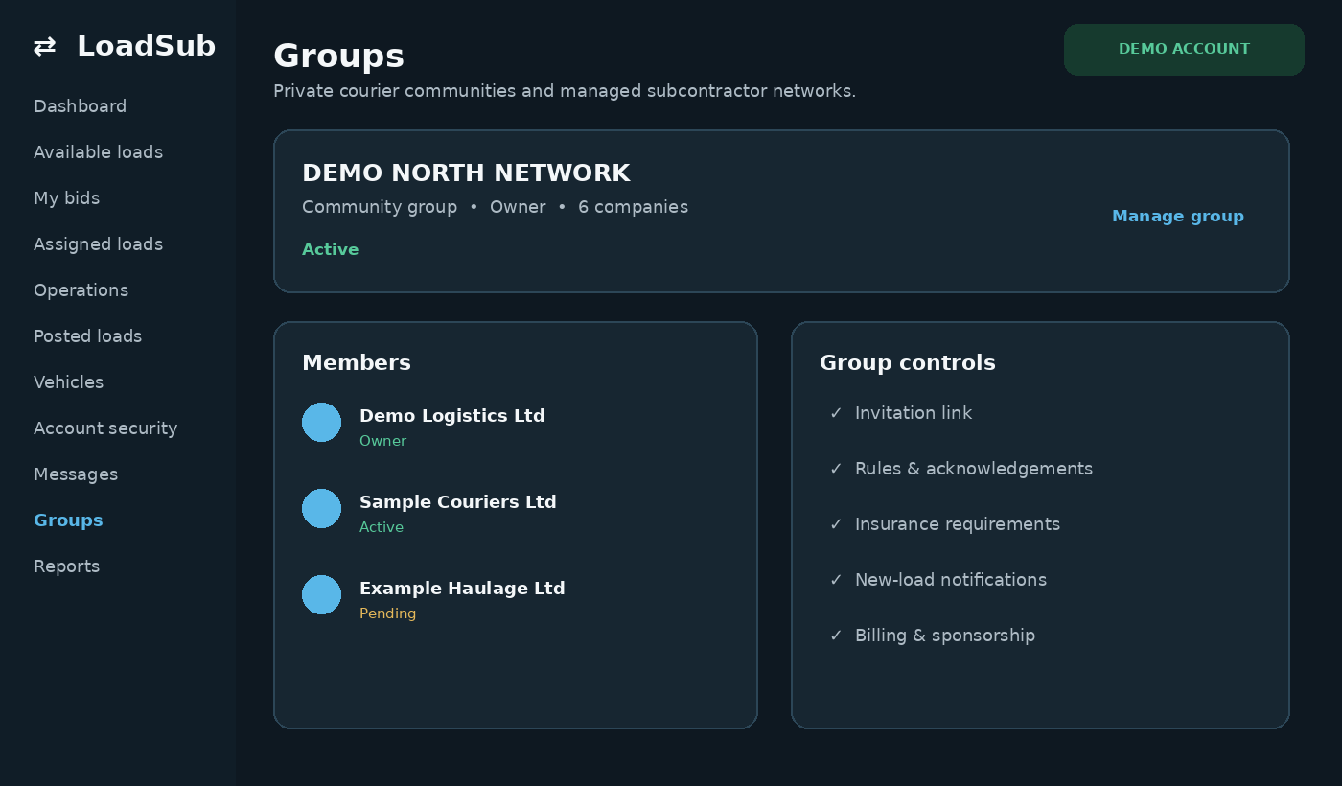
Synthetic LoadSub screen using demonstration data.

What is a private group?
An invitation only network in which approved companies share and manage loads. Owners control branding, membership, rules and compliance requirements.

How do I join a private group?
Open the invitation link, sign in or register, review the rules and apply. The group owner or administrator must approve the application before its work appears.

What is a managed subcontractor network?
A transport team can issue work to restricted subcontractor accounts. Subcontractors operate invited work without gaining unrelated group functions.

How do I create a group?
Choose Create group, select the type, then add branding and rules. Private community groups are free forever and include two owner controlled sponsored memberships. Managed subcontractor networks use seat based pricing.

Can bidding be paused without removing a member?
Yes. A group administrator can pause bidding and record a reason while preserving membership and history.

06 Posting and finding loads
Structured records keep timings, requirements and protected instructions together.
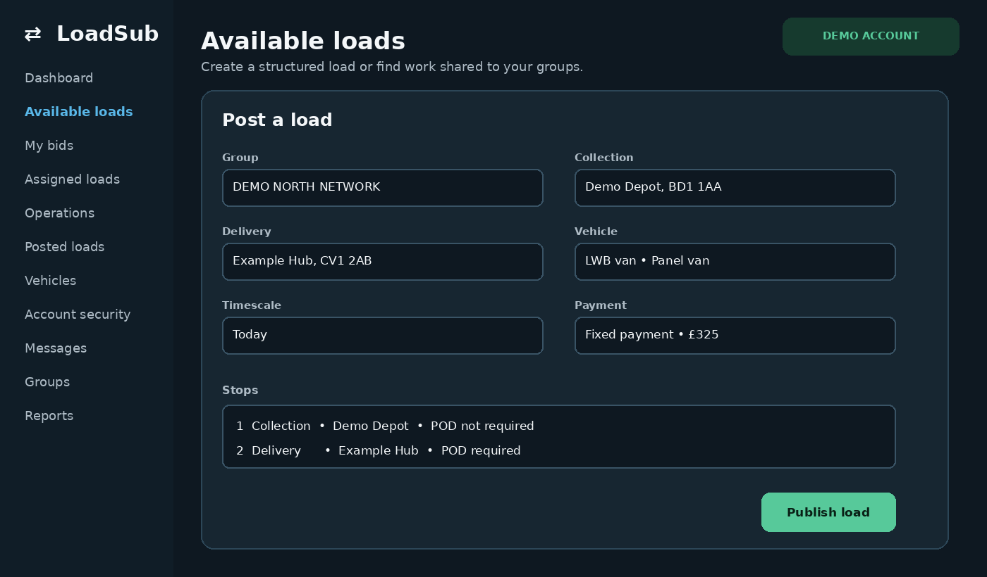
Synthetic LoadSub screen using demonstration data.

How do I post a load?
Choose Post load, select an eligible group, enter stops, timescale, vehicle requirements, description and payment method, then review before publishing.

What belongs in confidential stop details?
Put contacts, precise access information and operational instructions in protected stop fields. Keep the general description suitable for all eligible group members.

How do I find suitable work?
Use group, postcode, timescale, poster, vehicle, co load, radius and sort filters. Clear filters if results become unexpectedly low.

Why is a load missing?
Check group membership, bidding pause, insurance compliance, visibility, whether the load closed or was awarded, and active filters.

07 Bids and awarding work
Offers stay attached to the correct load and company.

How do I bid?
Open an available load, choose a suitable vehicle where required, enter the offered amount and submit any permitted timing proposal or note.

Can I withdraw or change a bid?
A bid may be withdrawn while the workflow permits. After award, use the formal withdrawal or cancellation process so the history remains complete.

How does a poster award work?
Open the posted load, compare eligible bids and accept the chosen offer. The carrier can then assign resources and receive confidential stop details.

Why can I not bid?
Typical causes are inactive membership, a bidding pause, missing insurance, an unavailable company account, a closed load or your own company having posted the load.

08 Assignment and live operations
Awarded work becomes an operational job with assigned resources and timed milestones.
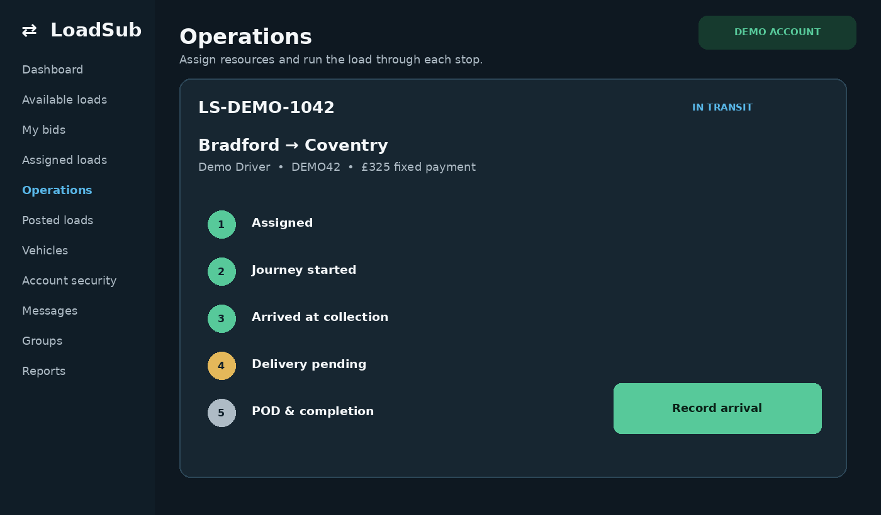
Synthetic LoadSub screen using demonstration data.

How do I assign a driver and vehicle?
Open the awarded load in Operations or Assigned loads, select eligible resources and save.

Why is a vehicle missing from the selector?
Check that it belongs to your company, is active, meets the load requirements and is not committed in a conflicting way.

What is the normal lifecycle?
Assigned work moves through journey start, arrival, stop completion and final completion. Record milestones in order.

What if the connection drops?
Do not repeatedly press the same action. Restore the connection, reload the record and confirm the last recorded milestone before continuing.

09 POD charges and invoices
Delivery evidence and commercial follow up remain connected to the load.

How is proof of delivery recorded?
At a POD required stop, record the recipient, date and time, signature where required, notes and permitted photo or PDF evidence.

Who can see POD?
The assigned carrier and poster can see completed evidence. Access follows the load relationship, not general group membership.

How are additional charges handled?
Record the charge against the load with a reason and evidence where required. The other party reviews it through the connected workflow.

When can an invoice be created?
Create it once the load and commercial state permit. Check completion, accepted charges and company tax details first.

10 Messages cancellations and disputes
Keep operational conversations and formal exceptions auditable.

Where should operational communication happen?
Use the message thread linked to the load. Pre bid and assigned load messages stay connected to the relevant parties.

How do cancellation and withdrawal work?
Use the formal poster cancellation or carrier withdrawal action, give the required reason and follow any consequence shown.

How do I raise a dispute?
Open the load case, select the category, provide a clear summary and attach only relevant evidence.

11 Reviews references and reputation
Verified feedback helps companies assess genuine working relationships.

Who can leave a verified review?
A company connected to a completed LoadSub assignment can leave Positive, Neutral or Negative feedback. The reviewed company can reply.

When does the positive percentage appear?
Only after at least five scored reviews, avoiding a misleading percentage from one or two jobs.

Can an unfair review be challenged?
Yes. Flag it and submit private counter evidence for adjudication. The decision can uphold, mute or remove it while retaining the audit record.

Can I provide a reference without a LoadSub load?
Yes. Business references are allowed and are labelled separately from assignment verified reviews.

12 Notifications reports and the app
Stay informed without keeping a desktop tab permanently open.

How do notifications work?
The notification centre keeps events that need attention. Browser alerts require permission and a supported browser.

What can Reports export?
Eligible managed network users can filter and export supported operational results by subcontractor, client, destination, date range or group.

How do I install LoadSub as an app?
Use the browser Install or Add to home screen option. The PWA uses the same account and permissions as the website.

13 Billing and subscriptions
LoadSub uses clear subscriptions and takes no cut from the value of work.

Does LoadSub charge commission?
No. LoadSub takes 0 percent of each load, bid or invoice value.

What does the 30 day trial include?
The company trial gives full company access for 30 days without a payment card. Managed subcontractor networks have their own 30 day evaluation.

Do private groups cost extra?
No. Private community groups are free forever and include two sponsored member accounts.

What are the Public Network tiers?
Post Loads is £10 per month at early adopter pricing, then £20. Post and Bid is £20 per month, then £30. Prices exclude VAT. Annual billing gives two months free.

What if checkout appears to fail?
Do not retry rapidly. Record the visible error and time, then check Billing to see whether the subscription was created. Never send full card details to support.

Before contacting support
Include the page name, record reference, your company role, the exact error, the time and timezone, browser or device, and whether one reload changed the result.
Never include passwords, two factor codes, full payment card details, session cookies or unrelated personal information.
Contact info@loadsub.com

Privacy
All signed in examples in this guide use synthetic companies, users, vehicles, loads and addresses. They contain no customer account data.

